STAGE 1 ACTIVITY – “ASSESS”

Activity Objectives:

- To consider the Public Health England (2015) Whole-School Approach principles, discuss and answer questions as a resilience team on how each principle applies to your school. Consider your evidence relating to each principle.
- To discuss what you are already doing well and identify any gaps, making notes on your resilience and emotional wellbeing record in the “Assess” columns.
- To begin the Resilience Toolkit, working towards the Kent School Award for Resilience and Emotional Wellbeing.

Resources Required:
- Time can be flexible but a good discussion with your resilience team members may take between 1 and 2 hours.
- Flip chart / whiteboard for note taking and pens.
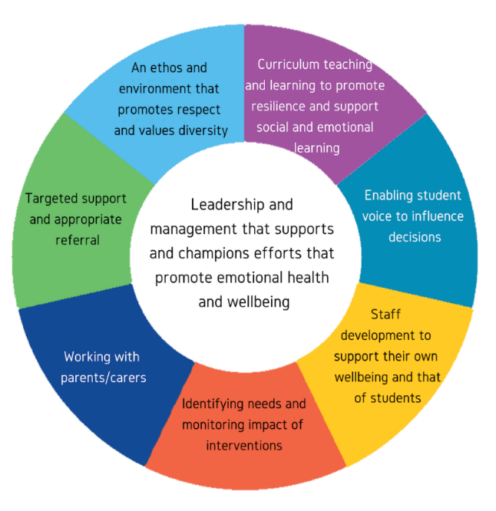
- Question prompts relating to each principle, cut out or projected onto a screen (see below).

Assessing
The following diagram represents eight principles to promote emotional health and wellbeing in schools and colleges through a Whole-School Approach (Public Health England, 2015):
Now that you have completed the ‘Getting Started with your Resilience Team’ activity, take a look at the 8 Whole-School Approach principles diagram as a team, and consider the activity below. Have your Resilience and Emotional Wellbeing record template ready to add in your findings.

Step 1: Cut each question box below into separate sections. If helpful, then split off into smaller teams to discuss a couple of questions each.
Step 2: Using the “Assess – what are we doing well?” column of your Resilience and Emotional Wellbeing record, record your answers to each question below, guiding you through the 8 principles one at a time. As well as what you already do well, ensure you also record any evidence you have relating to each of the principles. You can use the ‘Resilience Toolkit Examples of Evidence’ found at www.kentresiliencehub.org.uk to assist you in doing this.
Step 3: As you progress through the questions, you may identify some gaps in your current provision or highlight areas for development as well as your school’s current successes. Note down any gaps in the “Assess – even better if?” column of your resilience and emotional wellbeing record, as you will look at these in more detail as part of the “Planning” Stage (Stage 2).
*Top Tip*: It is a good idea to keep any notes you make during this process, as you may need them when gathering evidence towards applying for the Kent School Award for Resilience and Emotional Wellbeing.
3. Student voice: How does the school or college ensure all students have the opportunity to express their views and influence decisions?
1. Leadership and management: How is the school or college providing visible senior leadership for emotional health and wellbeing?
2. Curriculum, teaching and learning: What focus is given within the curriculum to social and emotional learning and promoting personal resilience, and how is learning assessed?

5. Identifying need and monitoring impact: How does the school or college assess the needs of students and the impact of interventions to improve wellbeing?
6. Working with parents/carers: How does the school or college work in partnership with parents and carers to promote emotional health and wellbeing?
4. Staff development, health and wellbeing: How are staff supported in relation to their own health and wellbeing and to be able to support student wellbeing?

8. School ethos and environment: How does the school or college’s culture promote respect and value diversity?
7. Targeted support: How does the school or college ensure timely and effective identification of students who would benefit from targeted support and ensure appropriate referral to support services?

Checklist
By the end of this “Assess” Stage you should have:
- Discussed the need for a Whole-School Approach when it comes to resilience and emotional wellbeing.
- Considered the differing needs of pupils, staff, parents/carers and the wider community.
- Considered areas of success, as well as any gaps. These immediate areas of success and your evidence, alongside any gaps, will have been noted down on your resilience and emotional wellbeing record.
Now that you have completed the “Assess” Stage, you are ready for Stage 2 - Planning Outcomes and Actions.

