First Name: | Surname: | DOB:  Date of conversation:
Name of worker having conversation: | Organisation: | Young person’s school:
Area of Resilience | Action
Feeling Secure - How secure you feel in yourself, in physical places, and with those around you.

Health - Your wellbeing and physical health and of those around you.

Emotions and Behaviours - Having the skills to manage your emotions and behaviours as well as feeling positive about the future.

Education - Your learning, trying new things, and the support from others to help with these.

Friendships - The importance of having friends, positive peers, and being a good friend.

Talents and Interests - Being able to access activities you enjoy, are good at, or want to do.

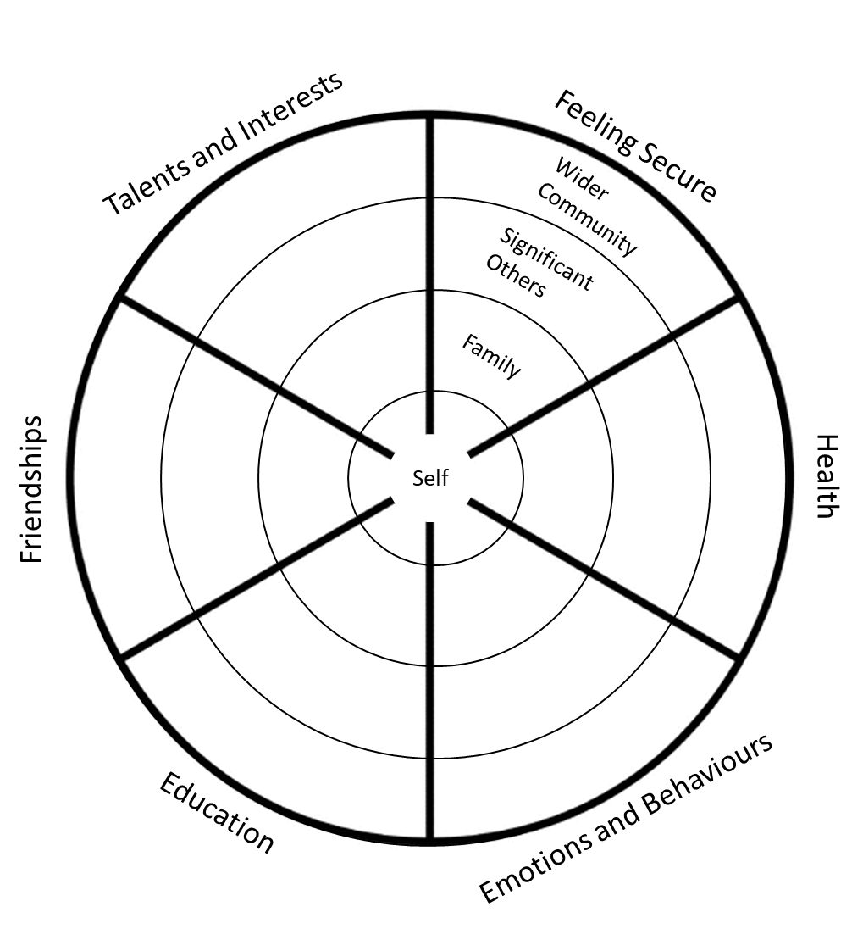

Support discussed (where available) | Offered | Interested
Safe space
Peer mentor
Online support & counselling
Volunteer mentor
Intensive mentor
Talents & interests grant
Family group work (transition)
All other services or support discussed:

To be read and completed by young person:

I give my consent for this tool to be seen by HeadStart Kent and any delivery partners who support me.

Signed: ....................................................................

Date: .....................................

Area of Resilience | Actions completed | What’s changed as a result?
Feeling Secure - How secure you feel in yourself, in physical places, and with those around you.

Health - Your wellbeing and physical health and of those around you.

Emotions and Behaviours - Having the skills to manage your emotions and behaviours as well as feeling positive about the future.

Education - Your learning, trying new things, and the support from others to help with these.

Friendships - The importance of having friends, positive peers, and being a good friend.

Talents and Interests - Being able to access activities you enjoy, are good at, or want to do.

First Name: | Surname: | DOB:  Date of conversation:
Name of worker having conversation: | Organisation: | Young person’s school:

Support discussed (where available) | Offered | Interested | Taken up | Completed
Safe space
Peer mentor
Online support & counselling
Volunteer mentor
Intensive mentor
Talents & interests grant
Family group work (transition)
All other services or support:

To be read and completed by young person:

I give my consent for this tool to be seen by HeadStart Kent and any delivery partners who support me.

Signed: ....................................................................

Date: .....................................

