Signing up for Delta to access your Coproduction training for children, young people, and adults e-learning.

When you create/register an account on Delta, you must supply your registration code. If this code is not supplied, your request for an account will be rejected and you will have to start again. For step by step instructions, please see below.
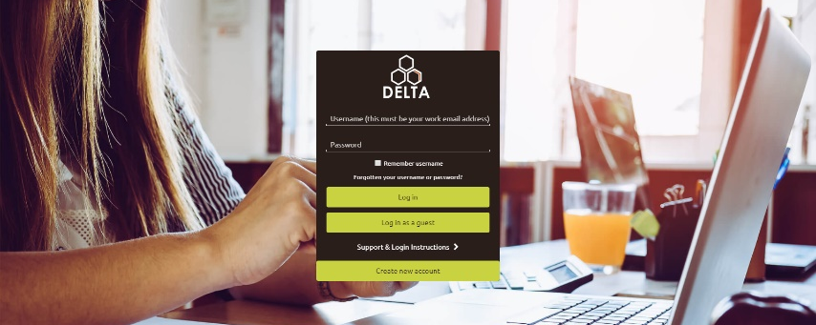
1: Go to www.delta-learning.com.
For the best experience, we recommend using Google Chrome or Microsoft Edge.

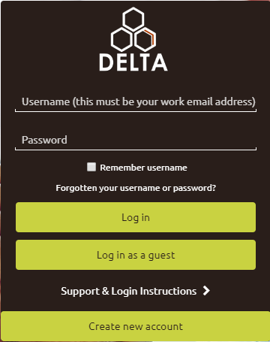

2: Click on ‘create new account’
at the bottom of the screen.

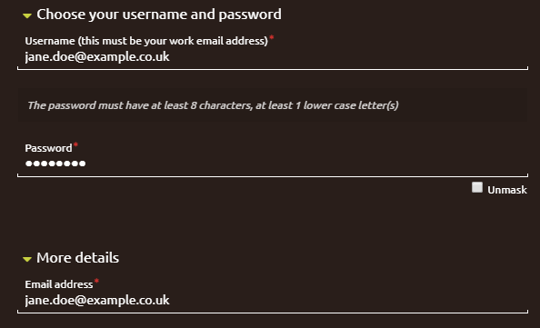
3: Follow the instructions shown to request your account. It is important that your username and email address match, so please take care when entering.

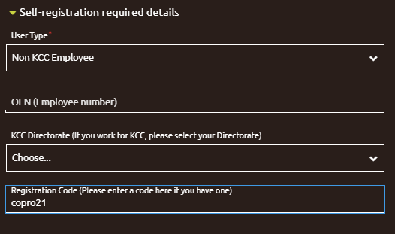
5: Click on the arrow next to ‘Self-registration required details’. For ‘User Type’ select Non KCC Employee.
Type in the Registration Code. If this code is not supplied, your request for an account will be rejected and you will have to submit another request.
Then click ‘request account’.

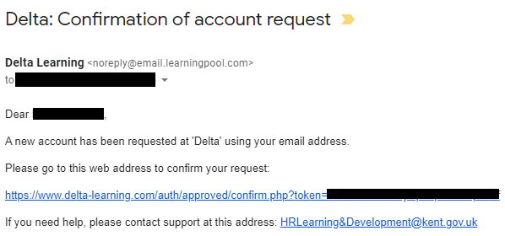
5: After you submit your request, an email will be
sent to your email address. Please click on the
web link it contains to confirm your email address.

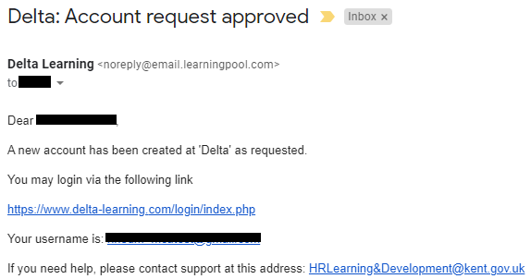
6: Please allow up to 72 hours for your account to
be approved. Once your account has been
approved you will receive an email confirming
this. You will then be able to access your course.

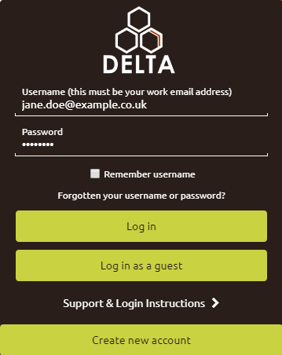

7: Once your account has been approved, go to
www.delta-learning.com and login with your username
and password you have set.

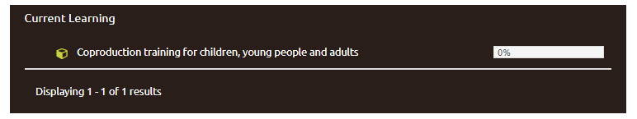
8: Once in your Delta account click on
Coproduction training for children, young people, and adults to be
taken to the e-learning content.

