The Kent Community Toolkit
for Resilience and Emotional Wellbeing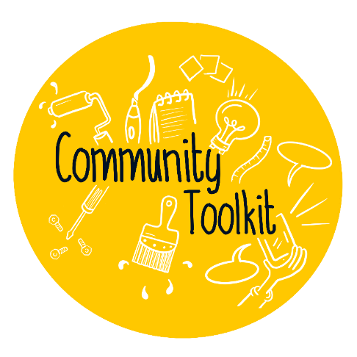
Community organisation:
Lead contact name:
Email address:
*Once you have completed the Assess and Plan stages, apply for the HeadStart community toolkit grant of up to £500 to support you with any key actions.*
*Once you have completed the Assess, Plan, and Outcome and Review stages, you will be ready to apply for the Kent Community Award for Resilience and Emotional Wellbeing.*

Contents
1. Leadership and Management 2
2. Activities and Learning Opportunities 3
3. Young People’s Voice 4
4. Staff Development and Wellbeing 5
5. Identifying Need and Monitoring Impact 6
6. Working with Parents and Carers 7
7. Targeted Support and Appropriate Referral 8
8. Ethos and Environment 9

Leadership and Management
Can you say… “our organisation has staff members who lead on promoting resilience and wellbeing”?
Assess - this works in practice by… |  | Assess – what is the evidence?
Who is your staff member who leads and/or champions resilience and wellbeing? What is their role?  How does this work? How do they champion resilience and wellbeing in your setting? |  | Examples could include…  Team meeting notes. Sessions delivered and/or plans. Feedback and evaluation. Policies.
Assess and Plan – are there any gaps? How will you fill them?
*Do not start the review stage until you have had time to implement any actions*
Outcome and Review – we can evidence we have filled the gaps through… | Outcome and Review – we know this now works because…
Date completed:

Activities and Learning Opportunities
Can you say… “our organisation provides activities and learning opportunities which focus on resilience, wellbeing and the development of social/emotional skills”?
Assess - this works in practice by… |  | Assess – what is the evidence?
What is your programme of activity? Does it include resilience and wellbeing? Do you give space and time to discuss wellbeing in group work / sessions? What key topics do you discuss and cover? |  | Examples could include…  Session plans. Timetables. Group work. Activities in action. Photos. Noticeboards/displays. Arts/crafts. Case studies. Young people’s feedback. National campaigns.
Assess and Plan – are there any gaps? How will you fill them?
*Do not start the review stage until you have had time to implement any actions*
Review – we can evidence we have filled the gaps through… | Review – we know this now works because…
Date completed:

Young People’s Voice
Can you say… “our organisation enables young people to influence decisions and express their views”?
Assess - this works in practice by… |  | Assess – what is the evidence?
How do you develop partnerships between young people, staff and volunteers? How do young people contribute and feedback? Do you have a youth voice group / forum / young people’s council? Do young people have the opportunity to develop and lead sessions / group work? Do you adhere to the Kent Youth Charter principles? |  | Examples could include…  Youth inclusion groups, feedback boxes/boards, surveys, meeting notes, session plans produced by young people, photos, case studies, direct feedback or quotes from young people.
Assess and Plan – are there any gaps? How will you fill them?
*Do not start the review stage until you have had time to implement any actions*
Review – we can evidence we have filled the gaps through… | Review – we know this now works because…
Date completed:

Staff Development and Wellbeing
Can you say… “our staff team are supported with their own health and wellbeing, and are able to support young people's wellbeing”?
Assess - this works in practice by… |  | Assess – what is the evidence?
Do you include wellbeing, resilience and mental health within team training? Does your team have access to supervision and support with their wellbeing? How is work/life balance addressed? How is team wellbeing promoted? What training opportunities and CPD opportunities do your team have access to? |  | Examples could include…  Training and CPD record/programme. Training attended. Supervision, support and resources offered. Policies. Feedback from team (direct, surveys). Team days.
Assess and Plan – are there any gaps? How will you fill them?
*Do not start the review stage until you have had time to implement any actions*
Review – we can evidence we have filled the gaps through… | Review – we know this now works because…
Date completed:

Identifying Need and Monitoring Impact
Can you say… “our organisation understands the needs of young people. Our organisation monitors the impact of interventions with young people”?
Assess - this works in practice by… |  | Assess – what is the evidence?
How do you assess the needs of young people? How do you use this as a basis for planning your activities and provision? How do you respond to young people’s identified needs? How do you monitor impact and outcomes? |  | Examples could include…  Demographic overview of your organisation. Staff discussions/briefs. Assessment tool/template. Resilience Conversation tool. Monitoring impact template. Activities which meet the needs of all young people.
Assess and Plan – are there any gaps? How will you fill them?
*Do not start the review stage until you have had time to implement any actions*
Review – we can evidence we have filled the gaps through… | Review – we know this now works because…
Date completed:

Working with Parents and Carers
Can you say… “our organisation works with, and involves, parents and carers”?
Assess - this works in practice by… |  | Assess – what is the evidence?
How do you involve parents/carers? What activities/sessions/opportunities do you provide for parents/carers? How do you make parents/carers aware of resilience, wellbeing and mental health sessions/resources? |  | Examples could include…  Events/activities. Surveys. Feedback. Photos. Communications (newsletter, website, social media). Parent/carer forum. Signposting to resources.
Assess and Plan – are there any gaps? How will you fill them?
*Do not start the review stage until you have had time to implement any actions*
Review – we can evidence we have filled the gaps through… | Review – we know this now works because…
Date completed:

Targeted Support and Appropriate Referral
Can you say… “our organisation provides targeted support and appropriate referrals when necessary”?
Assess - this works in practice by… |  | Assess – what is the evidence?
How do you identify young people who would benefit from targeted support and referrals to specialist services? How do you enable them to access support? What support/services do you offer? What external/partner agencies or organisations do you refer to and/or work with? How do you monitor the referral to an external organisation? |  | Examples could include…  Pathways. Staff team meetings. External meetings. Organisations you work with and refer to. Communication channels with organisations/partners. Case study. Communications (newsletter, website, noticeboard) with services available.
Assess and Plan – are there any gaps? How will you fill them?
*Do not start the review stage until you have had time to implement any actions*
Review – we can evidence we have filled the gaps through… | Review – we know this now works because…
Date completed:

Ethos and Environment
Can you say… “our organisation has an ethos and environment which promotes wellbeing, respect and diversity at its heart”?
Assess - this works in practice by… |  | Assess – what is the evidence?
How do you promote and support a culture of wellbeing, respect and diversity? Is there a culture of talking about resilience, wellbeing and mental health? Is it a safe environment which promotes positive behaviours? How do you ensure young people, your team, parents/carers and the wider community understand the importance of wellbeing? |  | Examples could include…  Session plans. Group work. Activities and events. Noticeboards/displays. National campaigns. Communications (website, newsletter, social media). A designated safe space for young people. Photos. Policies. Case studies. Feedback from young people, your team, parents/carers and visitors.
Assess and Plan – are there any gaps? How will you fill them?
*Do not start the review stage until you have had time to implement any actions*
Review – we can evidence we have filled the gaps through… | Review – we know this now works because…
Date completed:

