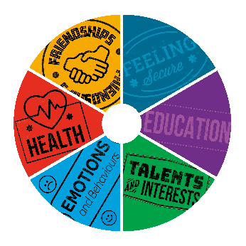
Think about the different areas in your life included in the circle below. Use red, amber, and green to rate which areas are going well, and which you would like to improve. Within each area, think about yourself, your family and friends, and your local community.

Talents and interests
Feeling secure
Health
Emotions and behaviours
Education
Friendships

Copy this image onto WhiteboardFox to use this tool online.

Use this space to note any key actions that may have come out of your conversation:

For further support options, please visit the Kent Resilience Hub.
To be read and completed by young person:

I give my consent for this tool to be seen by HeadStart Kent and delivery partners who support me.

Signed: .................................................................................... (Please initial if online) Date: .....................................

Worker: Please record the key details of your conversation here.

