The Kent Community Toolkit for Resilience and Emotional Wellbeing - Guidance

Contents
Introduction 3
Toolkit Stages 4
Stage 1: “Assess” 5
Stage 2: “Plan” 6
Stage 3: “Review” 7
Stage 4: Apply for the Kent Community Award for Resilience and Emotional Wellbeing 8

Introduction
Welcome to the Kent Community Toolkit for Resilience and Emotional Wellbeing. This Toolkit will guide you through the process of celebrating your community organisation’s good practice and what you are already doing well to support resilience and wellbeing. It will also help you put actions in place to develop this even further. At the end of the process, you can apply for the Kent Community Award for Resilience and Emotional Wellbeing, to recognise your hard work in developing your approach to resilience and wellbeing.
This Toolkit was developed by HeadStart Kent – find out more about the HeadStart programme here.
This Community Toolkit will take you through the process of assessing your community setting using eight whole setting approach principles:
1. Leadership and Management
2. Activities and Learning Opportunities
3. Young People’s Voice
4. Staff Development and Wellbeing
5. Monitoring Need and Impact
6. Working with Parents and Carers
7. Targeted Support and Appropriate Referral
8. Ethos and Environment.
These principles have been adapted from the Public Health England paper “Promoting children and young people’s emotional health and wellbeing: a whole school and college approach” (2015).

Toolkit Stages
Working through all stages of this Toolkit can take between 3 and 12 months, but this can vary depending on individual organisations. The Toolkit is designed to be completed by a team so that ideas can be shared, and actions allocated amongst the team.
HeadStart has developed a Community Resilience and Emotional Wellbeing Record to guide you through the stages of this Toolkit. The Record is designed to provide you with some key questions which need addressing whilst working through the Toolkit. However, please feel free to be creative when working through each Toolkit stage and ensure young people are involved wherever possible. Ultimately, the Community Toolkit and Award application should demonstrate the quality of your community provision and whole setting approach to wellbeing. There are useful resources to help you on the Kent Resilience Hub website.

Stage 1: “Assess”
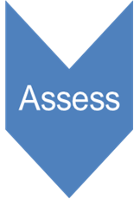
This is the stage where you will self-assess your community organisation’s approach to resilience and wellbeing. Your team will come together to consider what you already do well, where the evidence is found, and what the gaps are.
Within the Community Resilience and Emotional Wellbeing Record, focus on the blue “Assess” columns as you work though each of the eight whole setting approach principles. Within the Record are suggestions of how the criteria could be met:
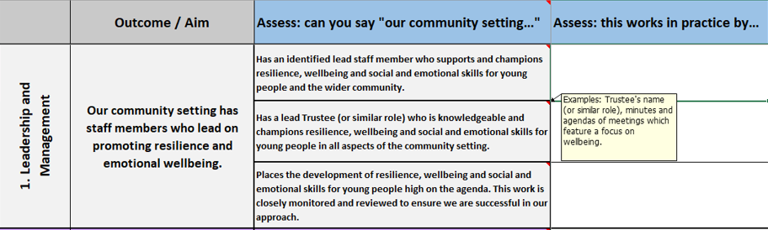
You can make notes within these columns (this can be bullet points and a list of any evidence):
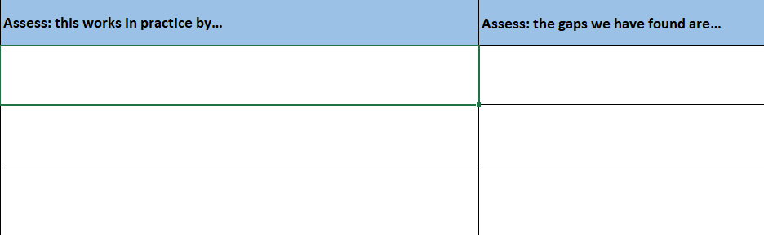
*Top Tip* Please save your Resilience and Emotional Wellbeing Record as you go as you will use this document at every stage.

Stage 2: “Plan”
Using your discussions and findings from the “Assess” stage, you are now ready to plan actions and outcomes. The “Plan” stage will enable you to plan any actions you would like to implement and consider what the evidence will be.
Use your Community Resilience and Emotional Wellbeing Record to make notes and plan your actions in the green “Plan” stage:
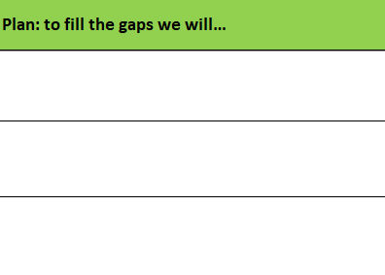
*Top Tip* You may not need to put actions in place relating to every whole setting approach principle. Your discussions during the “Assess” stage may have highlighted areas which are your strengths, and other areas where actions can be implemented.

Stage 3: “Review”
The “Review” stage is where you will reflect on and evaluate the impact and outcome of your actions.
*Top Tip* Do not start the "Review" stage until you have fully implemented your actions and have evidence to support this.
Use your Community Resilience and Emotional Wellbeing Record to make notes in the yellow “Review” stage:
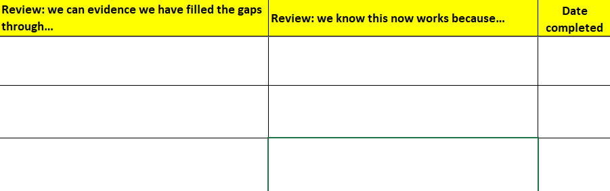

Stage 4: Apply for the Kent Community Award for Resilience and Emotional Wellbeing
Congratulations on working through all stages of this Toolkit and developing your whole setting approach! Once you have completed the “Assess”, “Plan” and “Review” stages you are ready to apply for the Kent Community Award for Resilience and Emotional Wellbeing. The Award is a recognition of your community organisation’s hard work and commitment to a whole setting approach to resilience and wellbeing. It is awarded by Kent County Council and The National Lottery Community Fund.
You can apply for the Award by following these steps:
- Please ensure you have completed the ‘Details’ tab of the Community Resilience and Emotional Wellbeing Record spreadsheet:
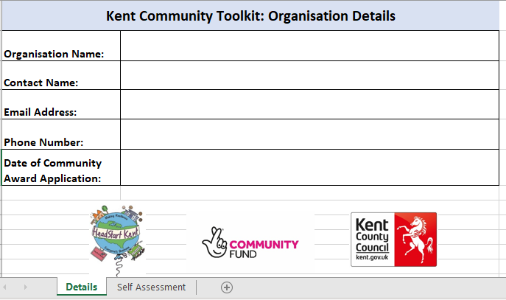

- Find the link to submit your Community Resilience and Emotional Wellbeing Record and details of any supporting evidence on the Kent Resilience Hub website.
Your application will then be reviewed using the criteria by a moderation panel within 6 weeks of receiving it. As a minimum requirement we will need to receive evidence for Young People’s Voice, Parents and Carers and Ethos and Environment which will be reviewed. Further evidence may also be requested by the moderation panel which will be reviewed; however, this will not exceed 6 pieces of evidence in total that is required.
HeadStart will keep you informed throughout the process, will notify you of any evidence requests and will contact you regarding the outcome of your application.
Once successful, a date will be arranged for your community organisation to receive the Kent Award for Resilience and Emotional Wellbeing. This will include a plaque for display and logo to include and promote on letterheads and/or a website.

