EMOTIONAL WELLBEING
The following guidance is based on the current evidence base and national guidance, as well as expertise from Educational and Mental Health Specialists across Kent. This guidance will help schools to make decisions on how to support their community’s emotional wellbeing, as well as knowing what to do if a member of the school community requires extra support or guidance. How both staff and students feel supported by schools on their return will determine how successful the transition will be. Likewise, those staff and students still working virtually need reassurance and support.
The experience of both staff and students will have differed; such as limited access to household space, financial hardship and lack of access and support for their education. Over the next months these issues may be exacerbated further. There may also have been increased exposure to domestic abuse, substance misuse and parental mental health. All students would have had limited social contact, with some very little. The loss of a loved one as a result of Covid 19 will also be a further issue schools will need to navigate.
For some, this time at home may have enabled improved relationships with carers and enabled students to have reduced anxiety about issues within school. Both issues could result in an increased anxiety or resistance about returning to work and school. Some students will also be deeply impacted by disruption to routine, the change in relationships with peers and teachers as well as the potential risk of an overloaded sensory environment.
The uncertainty of the depth and complexity of the emotional wellbeing issues which may arise in schools requires planning at the earliest stage. Schools should plan to ensure everyone feels included through an inclusive school culture; and that everyone can return to a positive and supportive working environment to help relieve anxiety and fear. However, despite living in unprecedented and challenging times, it is important to note that people’s response will differ according to their own experiences, internal and social resources. COVID may be traumatic for some, including our most vulnerable children and staff, but does not have to be traumatic for the majority.
Daily thought should be given to ensuring the whole school community, including staff and students, are welcomed and are given the opportunity for wellbeing check-ins within trusted relationships, enabling them to feel safe and part of a community which pull together and nurture each other. All staff should have a focus on the wellbeing of the whole community and pastoral staff are available and given the time to provide support.
Schools are a huge protective factor in promoting children’s resilience. Psychological adaption and re-orientation are already beginning to take place. Schools are already providing safe, stable and nurturing environments for their children and are already rich in resources to promote wellbeing. Should a child have experienced an actual trauma then a period of time adjusting to this is normal and most young people process this and accommodate the experience in an adaptive way. Also, we know that naturally processing trauma is more effective than formal treatment. However, if the young people is still experiencing PTSD symptoms one month on, then it is appropriate to seek formal support via CYPMHS
The Department of Education has published the following guidance to support the Emotional Wellbeing of student, staff and school population.
- Supporting wellbeing guidance from the DfE.
- Pastoral care in the curriculum
- Teaching about mental wellbeing
- Supporting Pupils Wellbeing The DfE have produced a leaflet with advice and links to resources to help teachers planning on having a wellbeing ‘check-in’ with their pupils Preview/download
- Emotional check in for ages 11+ - Anna Freud Centre resource encourages young people to think about the coping skills they have been using. Preview/download
The following additional Kent guidance and resources are designed to support schools with in-depth guidance and resources to support them to make decisions on how best to support their community’s emotional wellbeing, as well as knowing what to do if a member of the school community requires extra support.
The resources below have been coordinated and developed based on the current evidence base and national guidance, as well as expertise from the The Kent Specialist Teachers Service, Kent Education Psychology Service, KCC, The Education People, HeadStart Kent and Health partners. Each element includes different levels of response according to an individual’s level of need. The information is not designed to be sent out directly to children, young people, and parents and carers, rather to provide you with guidance and resources to support your conversations with them. The information below provides a summary of each section and are updated regularly.
All the resources below are updated weekly and are also hosted on Kent Resilience hub Covid 19 pages and young people can access content at https://moodspark.org.uk/.
CYP Kent Emotional Wellbeing flow chart - This directs staff to the most appropriate support for their students when faced with concerns about their emotional wellbeing or mental health. The flow chart includes reference to the Resilience Conversation Tool, which facilitates conversations with young people to listen to their experiences and can enable solutions to be found.

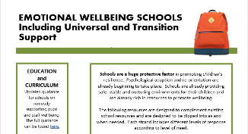
Emotional Wellbeing in Schools; including universal and transition support - Many schools are already providing safe, stable, and nurturing environments for their children and are rich in resources to promote wellbeing. This section contains bespoke resources for universal emotional wellbeing support, transition wellbeing and Early Years, if required. They include specific support for reintegration through checklists, toolkits, guidance and practical classroom resources.
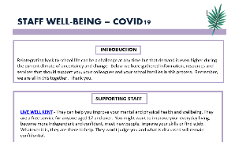
Staff Wellbeing - Reintegrating back to school life can be a challenge at any time but that demand is even higher during the current climate of uncertainty and change. Here you’ll find information, resources, training and services that should support you and your colleagues in this process.

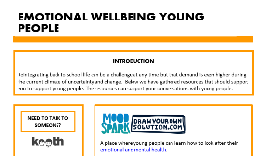
Emotional Wellbeing – Young People - This section highlights support available for young people to access independently, in addition or instead of support sought from school staff, carers, or friends. It includes a variety of means of support, for example, web-based guidance, online counselling, text support, phone calls, conversation tools, etc. These are known to encourage many young people to share how they are feeling and to reassure that it is normal to feel anxious at this time.
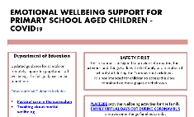
Emotional Wellbeing Support for Primary School Aged Children - Here you’ll find support options for primary-aged children and their parents/carers. The resources are predominantly focused on activities, mindfulness exercises, and supporting the understanding of the COVID-19 changes. The services referenced focus on The School Public Health Service through Children and Young People’s Counselling Services the CYP Kent Emotional Wellbeing services.
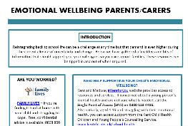
Practical Resources for Parents and Carers - The guidance in this section reflects the central role parents and carers play in developing their knowledge and skills to support the emotional wellbeing of their child as well as themselves.

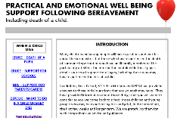
Practical and Emotional Wellbeing Support Following Bereavement - The extensive information, resources and services included in this section will provide support to practitioners to enable them to help children and young people following bereavement. The guidance can help to foster new networks of support and highlights a school’s role in providing routine and consistency when other aspects of life are disrupted The School Public Health Service through Children and Young People’s Counselling Services

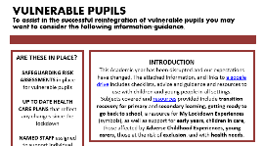
Emotional Wellbeing for Vulnerable Pupils - This is a new resource developed by STLS and KEPS, focusing on vulnerable students. The information included here features an additional google drive with checklists, activities and resources to use with children and young people in all settings. It also includes a link to Space Matters, Kent and Medway’s approach to support trauma informed approaches and guidance for schools

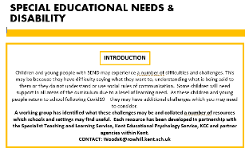
Emotional Wellbeing – Young People with Special Educational Needs and Disabilities - Some students will need support in all areas of the curriculum due to a level of learning need. As these children and young people return to school following Covid19 the resources in this section will be able to direct staff to appropriate support. This section is also supported by a google drive containing practical resources, links to services and risk assessments.

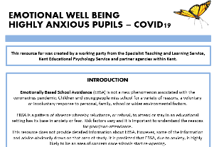
Emotional Wellbeing – Highly Anxious Students - Here you’ll find additional resources developed by STLS and KEPS providing initial guidance to meet the immediate challenges for highly anxious students who are perhaps not attending school. The google drive includes an introductory brief guide to anxiety, tools to ‘measure’ anxiety and create a back to school plan, resources for interventions, whole school good practice, tools for managing anxiety during (and after) the Covid-19 pandemic, recommended reading and further suggested resources.

