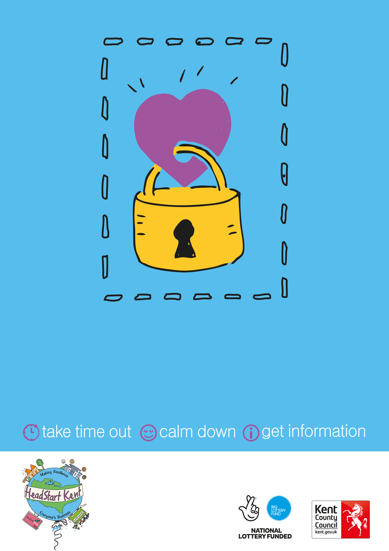

Open from 0:00am until 0:00pm

Location: Xxxxxxxxxx

Safe Space